1.The first step is to verify and ensure that both

SQL Server and SSMS
are configured to use SSL/TLS encryption.

1. So on ssms
verifying that the "Encrypt connection" option is checked in the "Connect to Server" dialog when establishing a connection to the SQL Server instance. This setting ensures that SSMS uses SSL/TLS encryption for the connection, which is essential for secure communication and can help resolve SSL certificate trust issues.
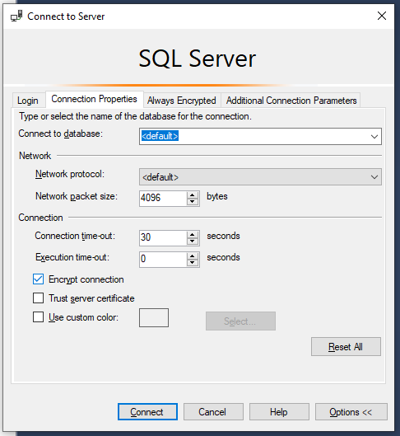

By checking this option, you're configuring SSMS to use SSL/TLS encryption for the connection to the SQL Server instance.
essential for resolving SSL certificate trust issues.

2. ensure SQL Server is configured to allow remote connections.

2.1.Enable TCP/IP Protocol:

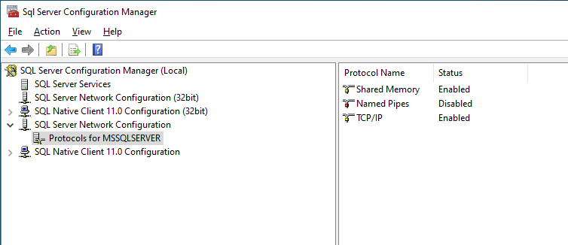

2.2 Enable Remote Connections in SQL Server

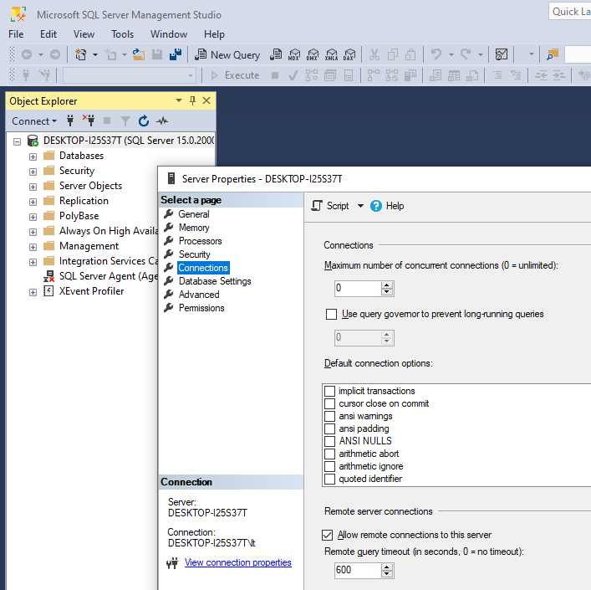

Integrated Security=true
means that the application is using Windows Authentication to connect to the database.

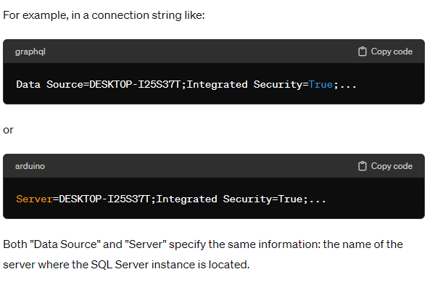

for developer edition with media you wouldn't typically use (LocalDB) in your connection string.

The error message you received indicates that there's an issue with the SSL certificate chain being used for encryption during the login process. Here are some steps you can take to troubleshoot and potentially resolve this issue:
- Verify SSL Certificate:
  - Check the SSL certificate being used by the SQL Server instance. Ensure that the certificate is valid and has been issued by a trusted certificate authority (CA).
  - Make sure the certificate hasn't expired and is properly configured on the SQL Server.
- Check Certificate Authority:
  - Verify that the certificate was issued by a trusted certificate authority. If the certificate was self-signed or issued by an internal CA, ensure that the CA's root certificate is trusted on the client machine attempting to connect to the SQL Server.
  - If necessary, install the root certificate of the certificate authority on the client machine.
- Certificate Configuration:
  - Ensure that the SQL Server instance is configured to use the correct SSL certificate for encryption.
  - Verify that the certificate's subject name matches the server's hostname or IP address that clients use to connect to the SQL Server.
- Client Configuration:
  - If you're connecting from a .NET application or another client, ensure that the client application trusts the SSL certificate used by the SQL Server instance.
  - Some client libraries have options to ignore SSL certificate validation errors. While this can be used as a temporary workaround for testing, it's not recommended for production use due to security implications.
- Check SQL Server Configuration:
  - Ensure that the SQL Server instance is configured to enforce SSL encryption for client connections, if required.
  - Check SQL Server's SSL settings in SQL Server Configuration Manager to ensure that SSL encryption is enabled and properly configured.
- Restart Services:
  - Sometimes, restarting the SQL Server service and the client application can resolve transient SSL-related issues.
- Review Logs:
  - Check SQL Server error logs for more detailed information about the SSL handshake process and any errors encountered.
  - Review the Windows Event Viewer logs for any relevant SSL-related errors or warnings.

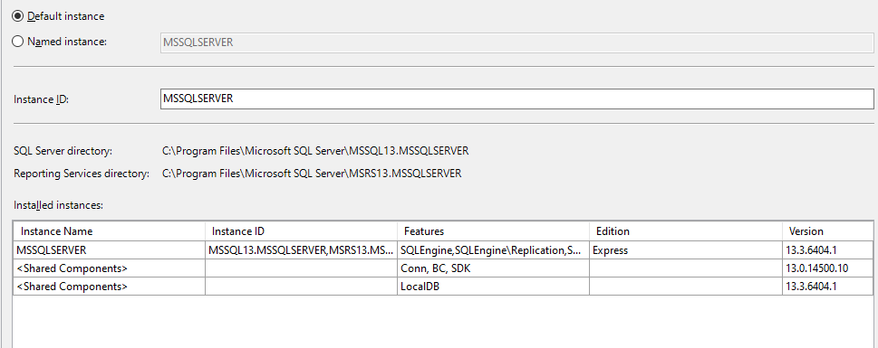

MSSQLSERVER

Check SQL Server Services: Make sure the SQL Server (MSSQLSERVER) and SQL Server Browser services are running. You can check this by going to Windows Services (services.msc) and verifying the status of these services.

Missing lo0caldb

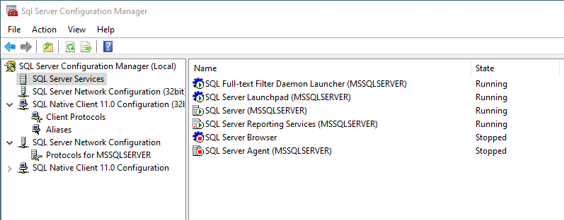
sql server installation

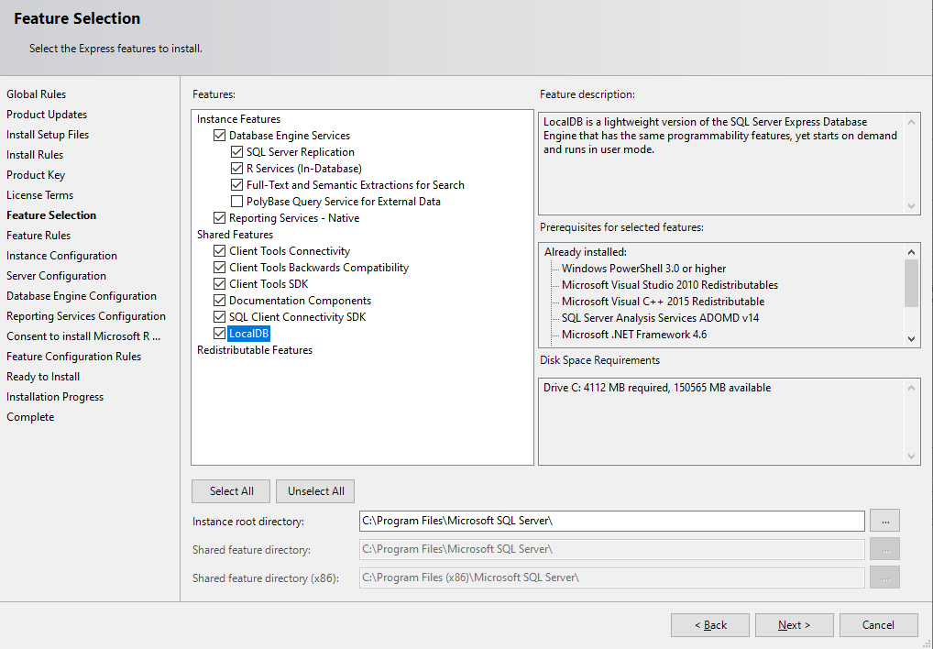
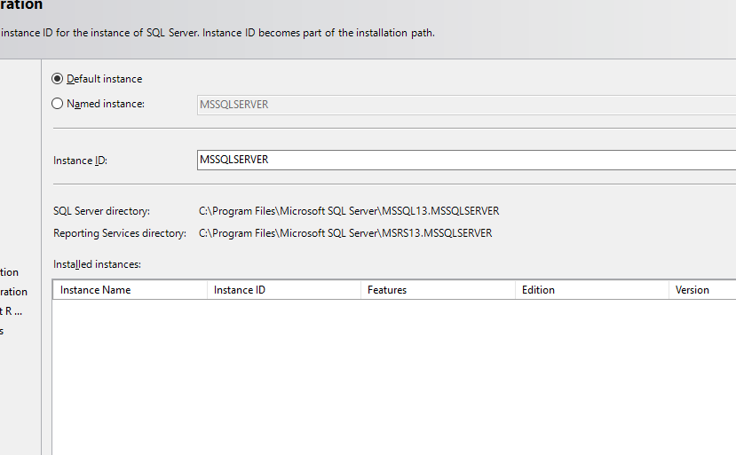

MSSQLSERVER
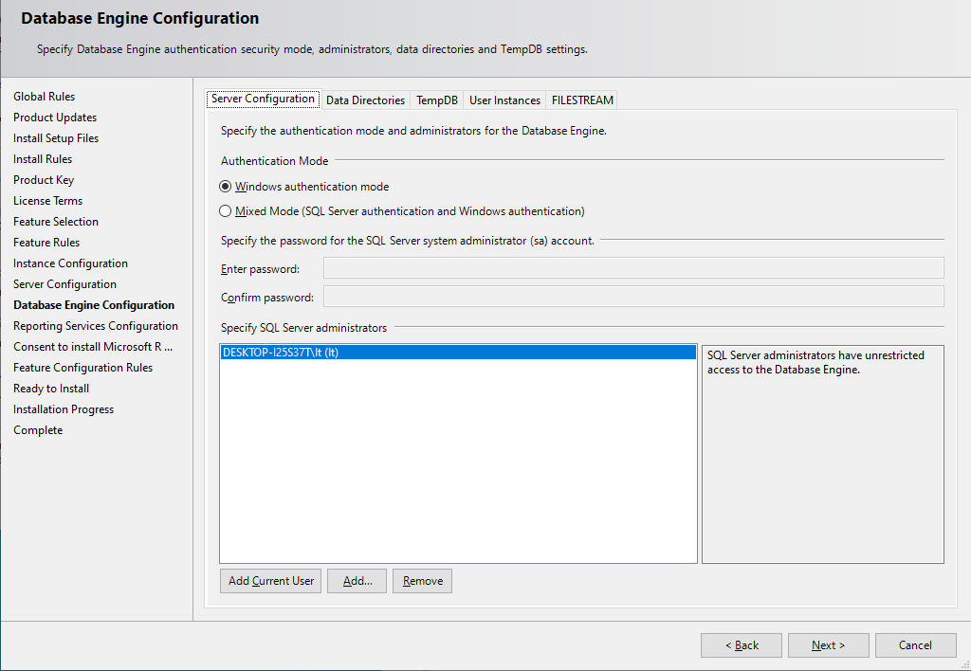

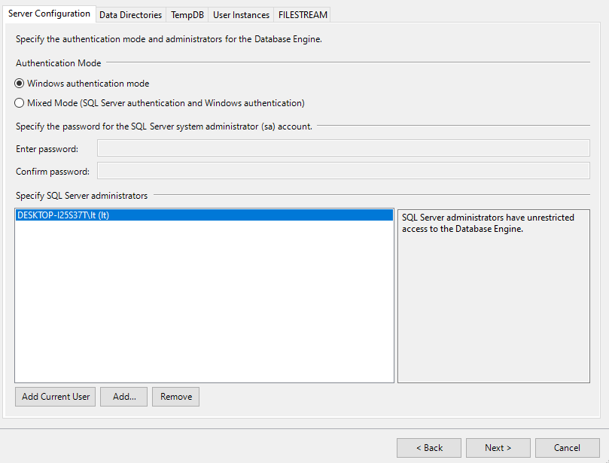

C:\Users\lt\AppData\Local\Microsoft\Microsoft SQL Server Local DB\Instances

